Computerized Patient Record System Loader
Manual
Version 1.0



July 2014

Department of Veterans Affairs
Office of Information & Technology (OI&T)
Product Development (PD)

This page left intentionally blank.

Revision History
Date | Version | Description | Author

Table of Contents
1 Computerized Patient Record System Loader 1
1.1 Overview 1
1.2 Recommended Audience 1
1.3 About this Manual 1
1.4 National Deployment 1
1.5 Document Conventions 1
1.6 Related Documents 1
2 CPRSLoader v1.3 Installation Checklist 2
Select a machine not used for production. 2
3 Software Retrieval 2
4 Installation 2
4.1 Installation Procedure Changes for the CPRS GUI 2
4.2 Overview of the new process: Loader in front of CPRS 2
4.3 Changes for the End User 4
4.4 Automation Capabilities 4
4.5 Manual Installation 4
4.5.1 Things that should be done beforehand: 4
4.5.2 To install manually on a workstation, follow these steps: 4
4.6 CPRS Documentation 9
Appendices 9
Appendix A Troubleshooting Guide 9
A1 Interface: Visual GUI and Switches 9
A2 Uninstallation 11
A3 Dual Shortcuts 12
A4 Self-Repair 13
A5 Version numbers—Loader versus CPRS 13
A6 Batch File 13
A7 DLL Distribution 13
A8 Delay Updating from MSP File during Installation 13
A9 Do Not Modify the MSI and MSP Files 14

This page left blank intentionally.

Computerized Patient Record System Loader

Overview
The Computerized Patient Record System Loader (CPRS Loader) is a Delphi application used to facilitate updating the CPRSChart executable on user desktops. CPRSLoader is used in conjunction with Windows Installer patch files (.msp) to overcome the limitation on Windows 7 machines requiring administrator rights to place the executables in the proper spot on the target machines.
This manual deals specifically with the installation of CPRSLoader version 1.3. Version 1.3 is meant to address a few issues: startup speed on a network; patches rebooting the machine without warning; and a few registry issues.

Recommended Audience
This guide provides information specifically for Department of Veterans Affairs Medical Center (VAMC) Information Resource Management (IRM) staff.

About this Manual
This manual provides:
- Instructions for installing the CPRSLoader executable on workstations at VAMC facilities
- Instructions for using the CPRSLoader to install CPRSChart msp files
- Information on visual diagnostic tools accessed by command line switches
- A troubleshooting guide for known issues.

National Deployment
CPRSLoader 1.3 is meant to be deployed with a SCCM package prior to CPRS v30.B. The package may be deployed any time prior to the release of CPRS 30.B.
CPRSLoader 1.3 may also be manually copied into place by a user with administrator rights, if desired.
CPRSLoader isn't used on server or Citrix based deployments of CPRS.

Document Conventions

Related Documents
The following documents, in addition to this document, are available on the VA Software Document Library (VDL):
CPRS on the VDL
- none

CPRSLoader v1.3 Installation Checklist
The following activities should be completed in order.
Table 1 Installation Checklist
No. | Item | Done
Read previously supplied documentation:
- CPRSLoader Manual
Test/Mirror System Installation
 | Select a machine not used for production.
 | Download CPRSLoader.exe from the ftp server.
 | Install CPRSLoader onto the test machine, using the instructions in section 4.5 Manual Installation.
 | Verify the installation on the test machine has been successful.
Production/Live System Installation
 | Run the SCCM package for CPRSLoader.
 | Verify the installation in your Production/Live system has been successful.

Software Retrieval
CPRSLoader 1.3 consists of a single executable, and a System Center Configuration Manager (SCCM) package that will be replicated onto the SCCM servers by the national SCCM team at a time of their choosing.

Installation

Installation Procedure Changes for the CPRS GUI
Due to file writing permissions introduced by the Windows 7 operating system, the previous automated method for updating CPRSChart is no longer available. Installation into the Program Files directories now requires administrator rights, which are not available to the standard user. Digital certificates can be used in place of administrator rights for installations, so a change was made to the installation model for CPRS.

Overview of the new process: Loader in front of CPRS
First, a Microsoft Installer file (msi) will be run on the workstation by either a SCCM push or by a local administrator. This will install the CPRSLoader application, which is an upgraded CPRSUpdater. The loader needs to be installed with Vista server information (vista server fully qualified domain name (FDQN) and remote procedure call (RPC) port number) as well as the location of the gold directory.
Once that is completed, end users will have a normal CPRS icon placed on their workstation, which will run the loader prior to starting up CPRSChart. The loader checks the gold directory for new updates, installs any necessary updates (msp files), then starts up CPRSChart.
- Previous gold path process
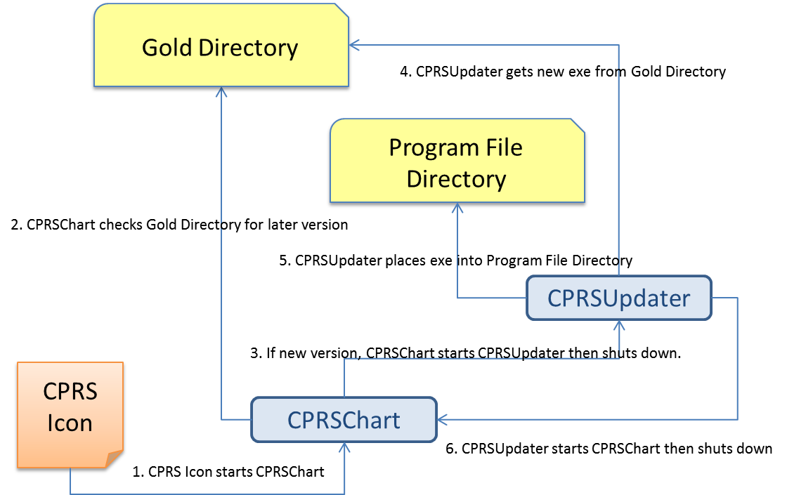
- Updated gold path process
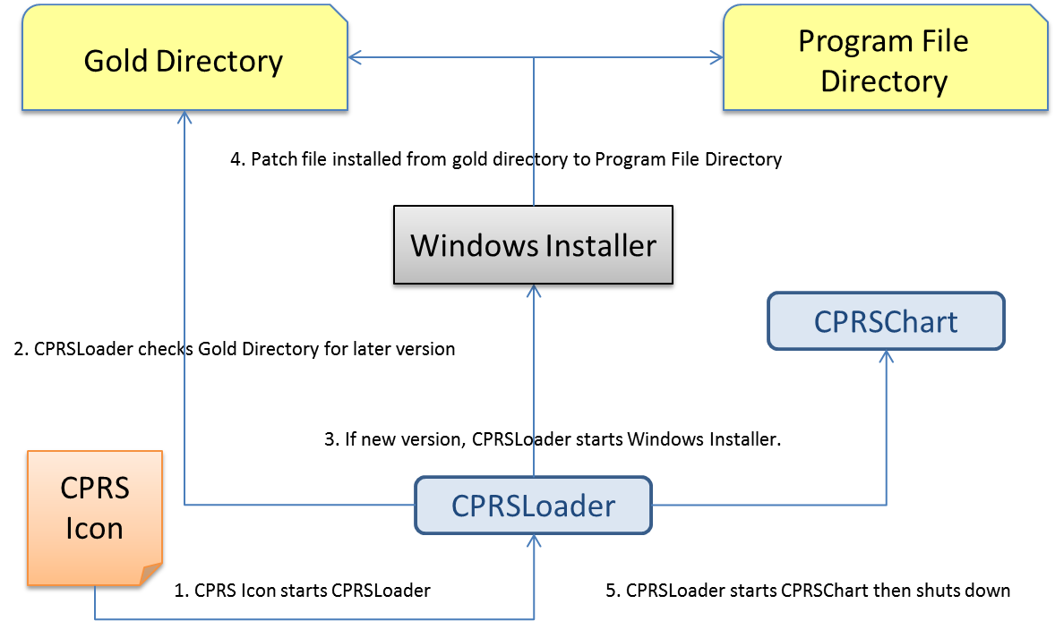

Changes for the End User
There are no visible changes in the end-user process; except possibly the icon name. An icon from a previous CPRS installation may still be visible on the desktop for some users. These differences will need to be taken care of locally.

NOTE: Users might notice a delay when the installer file is run for the first time, as it takes some time to run and installs shortcuts on the workstation. Later patches will have varying delays, depending on the content in the patch file.

Automation Capabilities
This installation is meant to automate the CPRS installation process. This is accomplished by a combination of SCCM, MSI, and CPRSLoader settings. This is the preferred method for installing on a local workstation. To set up the automation, a site must determine which server name, port, and gold directory location they are using.
- The server name is either the DNS name of the server Vista resides on (e.g. \\vista.server.va.gov), or its IP address (e.g. 10.1.2.34, etc.). Of the two, the use of a DNS name is preferred—for load balancing purposes.
- The port is the port the RPC Broker listens on for the particular instance of Vista (e.g. 5529).
- The gold directory is the location where any files that will automatically update CPRS will be placed (e.g. \\server.va.gov\CPRSGold)
To begin the process, contact the local SCCM manager and find the CPRS Install package. It may be labeled for CPRS v29, as that is the first application to use it. The package should have been replicated to all sites in the fall of 2013. Once the initial files are pushed to the workstations, the rest of the automation consists of copying the appropriate patch file into the gold directory. Alternatively, another SCCM push could also do that step, to avoid large numbers of users accessing the gold directory concurrently.

Manual Installation
Manual installations are used for installing on machines specifically testing the loader, new installations of CPRS on a desktop, after CPRS is uninstalled for whatever reason, and to correct problems with a previous installation (SCCM failure, lack of proper permissions, etc.).

Things that should be done beforehand:
- Set up a gold directory for the site that CPRS users can read files from.
- Determine the DNS server name or IP address for the appropriate VistA server.
- Determine the Broker RPC port for the VistA account.
- Acquire the CPRS.msi file, and the latest CPRS.msp patch file, if any.

To install manually on a workstation, follow these steps:
- Double click on the CPRS.msi file.
- A Welcome screen shows—Click on the Next button.
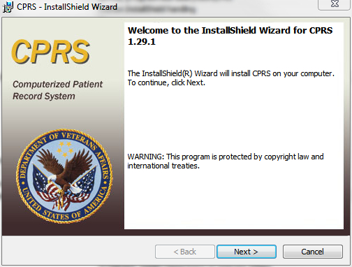
- A Destination Folder dialog shows.
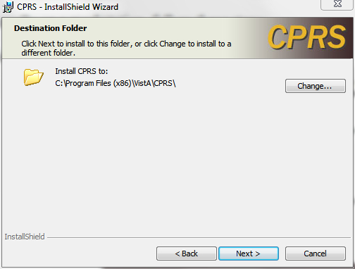
If the installation destination shouldn't be the default (c:\Program Files (x86)\VistA\CPRS), change it by clicking on the Change button, which shows the Change destination dialog.
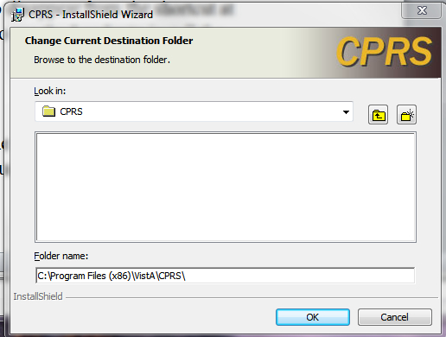
Find the desired directory and select OK, or to go back to the default directory, select Cancel.

- A VistA Connection dialog shows.
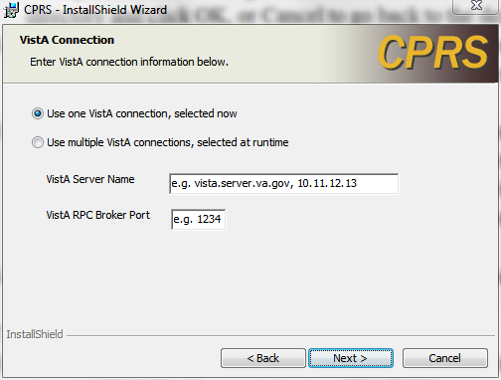

For users that have more than one VistA account to access with the GUI, select the “Use Multiple VistA connections…” radio button. This will disable the VistA Server Name and VistA RPC Broker Port prompts in the dialog—the user will be prompted for this information at runtime when the dialog appears with the drop-down box to select the account the user wants to log in to.

For a single VistA connection, select the first radio button, “Use one VistA connection…” and enter the VistA Server Name (either the fully qualified domain name or the IP address) and VistA RPC Broker Port number at the prompts supplied. This would be similar to adding them to the CPRS icon on the desktop using the Properties option and entering a serve and port number in the Target field.
- An Automatic Update dialog shows.
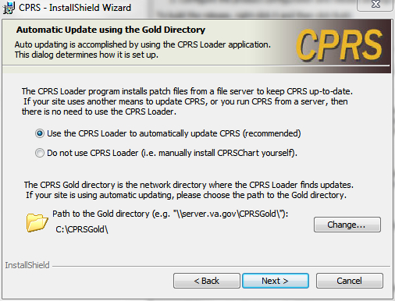
If manual-only updates are preferred, choose the radio button “Do not use CPRS Loader…”, which means updating the CPRSChart executable, as well as supporting files, will need to be done in another manner. For a normal desktop installation, leave this setting at the recommended “Use the CPRS Loader…”
If necessary, change the default gold directory by selecting the Change button, selecting the appropriate directory from the Change directory dialog and then selecting OK.
Click on Next once the path to the gold directory is correct.

- The Shortcut Choices dialog shows.
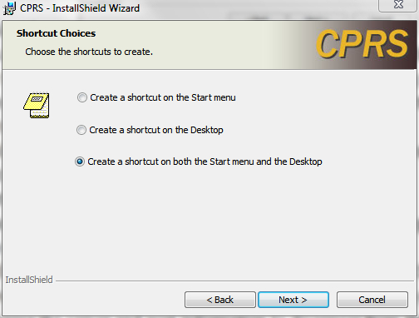
Choose where the icons should appear using one of the three radio buttons.
Click on Next.
- The Ready To Install dialog shows.
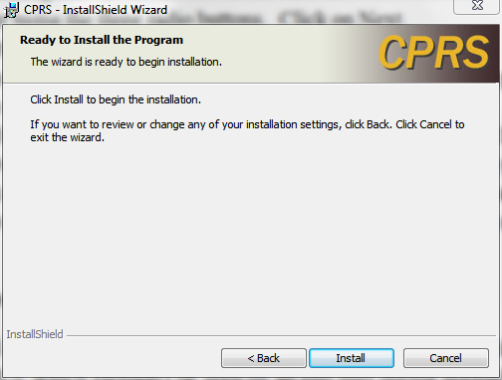
Select the Install button and wait for the installer.

- A dialog with a status bar will appear and show the progress of the installation

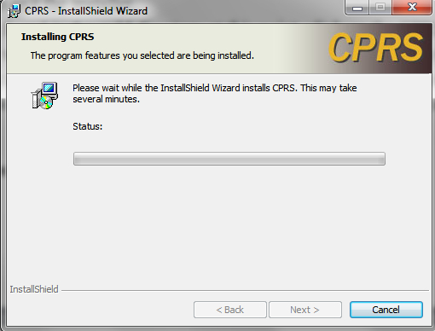

- Then an installation complete dialog shows. 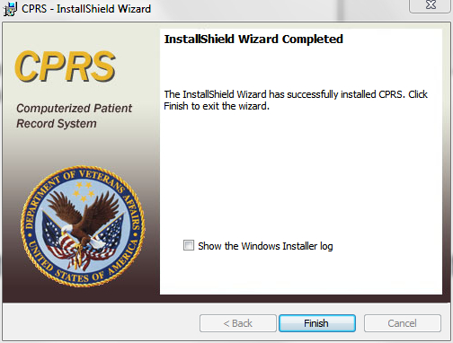
- Click Finish to exit the installer.

- To install any patches found in the gold directory at this point, click on the CPRS shortcut icon and the CPRS Loader will look for the latest patch and install it. The patch may be clicked on directly, but this may cause the server and port information to disappear from the shortcut at times due to a Windows Installer bug, so it is recommended to use CPRSLoader to install the patches.

CPRS Documentation
Currently, this is the only document being provided for CPRSLoader.

  - Troubleshooting Guide
    - Interface: Visual GUI and Switches
There are two Graphical User Interfaces (GUIs) used during this process. The first one is the MSI GUI, which is detailed in section 4.5.2, To install manually on a workstation, follow these steps, above and the CPRSLoader GUI, which shouldn't be seen by an end user during normal operation. With the switches available, it doesn't need to be seen at all.
The switches are as follows:
SHOW Shows the loader's GUI. The GUI is invisible if this switch isn't used.
GOLD=filename Changes the gold directory for the auto-update feature.
SetCPRS=filename Changes the location the loader looks for the current CPRSChart.
SetServer=servername Changes the DNS server name for the VistA server CPRSChart uses.
SetPort=portnumber Changes the broker port for the VistA account CPRSChart uses.
FORCE Forces the installer to run the latest patch file.
LOGLOAD Creates a log file named CPRSLoader.log in the user’s document directory.
The main screen looks like this:
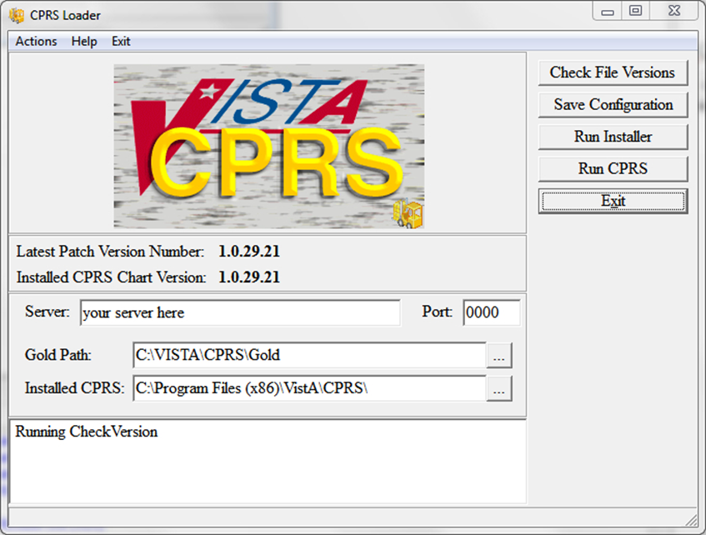
It shows information on the current CPRS setup, and provides some buttons and menu items for operating the loader. Upon start up, the loader checks version information for the latest patch, as well as for the CPRSChart.exe and will display the results.
Latest Patch Version Number: This displays the latest patch version number located in the gold directory. It is blank when a valid patch isn't found. Patch names must be prefixed with “CPRS”, be built for CPRS, and have a filename extension of “.msp”.
Installed CPRS Chart Version: This displays the latest file version of the copy of CPRSChart.exe located in the install directory. It is blank when CPRSChart.exe is missing.
Server: This is the default DNS name passed by CPRSLoader to CPRS when it starts CPRSChart. It can be changed in the edit box. The Save Configuration button must be used to save the value for subsequent uses.
Port: This is the default RPC Broker port the loader passes to CPRS when it starts CPRSChart. It can be changed in the edit box. The Save Configuration button must be used to save the value for subsequent uses. Entry is limited to numeric values only.
Gold Path: This is the location where the loader looks for patch files. It can be edited in either the edit box, or by using the ellipsis button following the edit box, then choosing a directory from the popup dialog. The Save Configuration button must be used to save the value for subsequent uses.
Installed CPRS: This is the location of CPRSChart.exe, which is called by the loader. It can be edited in either the edit box, or by using the ellipsis button following the edit box, then choosing a directory from the popup dialog. The Save Configuration button must be used to save the value for subsequent uses.
Log Memo: The memo box at the bottom is used for the loader log function, and displays a status while the application is running.
Check File Versions: This button tells the loader to re-check the version information—useful if the gold path or install location has been manually changed.
Save Configuration: This button tells the loader to save the configuration information entered into the visual controls to the computers registry files.
Run Installer: This button tells the loader to run the latest patch file.
Run CPRS: This button tells the loader to run CPRS with the values shown.
Exit: Leaves the loader application.
Actions Menu: The items in the actions menu perform the same actions as the buttons with the corresponding labels.
Help Menu: Shows the switches the loader may use.
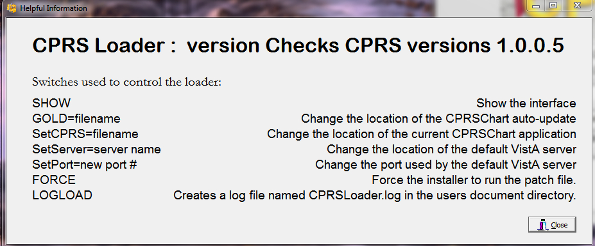

Exit Menu: Leave the loader application.

    - Uninstallation
The uninstaller can be run from the Programs and Features list in the Control Panel or it can be run by clicking on the msi installer file. Choose the Remove option to remove both CPRSLoader and CPRSChart from the install directory.
Warning: This will remove them from the Programs and Features list as well. If VA CPRS v29 was installed on the workstation, the older CPRSChart from v29 will not be restored, but a repair installation of the VA CPRS item may restore it. If VA CPRS is uninstalled, it will delete the latest patch applied to the workstation, but running the loader again will reinstall it.
The uninstaller can be run from the Programs and Features list in the Control Panel or it can be run by clicking on the msi installer file. Caution should be used when uninstalling—there are some idiosyncrasies due to changes in the methods used to address Windows 7 installation requirements, namely:
- Under “Control Panel” -> “Programs and Features” there may be two separate instances of CPRS represented after CPRS v30.A has been installed. If so, they will appear as:
  - “VA CPRS” (this is version 29)
  - “CPRS” (this is version 29)
- Uninstalling EITHER of these versions will remove CPRSChart.exe from the local workstation’s Program Files folder
- Do not uninstall v29 unless the installation of v30.A is going to immediately follow.
- It is not actually necessary to uninstall v29 (the “VA CPRS” entry in Control Panel Programs and Features) since the GUI executable (CPRSChart.exe) will be replaced. However the old v29 (“VA CPRS”) may remain in the Control Panel Programs and Features.
- If you do uninstall v29 (VA CPRS) AFTER v30.A has been installed, then the v30.A version of CPRSChart.exe will be removed—simply running the v30.A CPRS shortcut (see A3, Dual Shortcuts, below) should reinstall the patch –(seek IT support if that doesn’t work )
    - Dual Shortcuts
Dual CPRS shortcuts may appear on the desktop. This is due to the new installer creating a shortcut to run CPRSLoader instead of the previous method of directly running CPRSChart. This may have different effects depending on the workstation’s installation. If this does happen, the simplest fix is for the user to delete the old shortcut and start using the new one.
To identify which shortcut is the correct one (if the version number is not in the name), use these steps:
- Right-click the shortcut icon.
- Select Properties.
- Select the Shortcut tab.
- Look at the contents of the “Target” text box (you may have to put your cursor in the box and scroll to the right to be able to see the end of the string) and see if it ends with CPRSChart.exe (v29) or CPRS Loader.exe (v30.A).
- The shortcut going directly to CPRSChart.exe is the one to remove.
If it is a Windows XP workstation, both shortcuts will check for updates and start CPRSChart normally; the old shortcut will use the CPRSUpdater, and the new shortcut will use CPRSLoader. They have the same effect on an XP workstation.
If it is a Windows 7 workstation, both shortcuts will run v29, until v30.A is installed. At that time, the old shortcut will cause CPRSChart.exe to fail, due to a missing switch, and wouldn't be able to update. The new shortcut will work properly. Ideally, desktop support may be able to arrange a way to automatically delete the old v29 shortcut.
      - CPRS Not Starting
If the user has trouble starting CPRS after the CPRSLoader v1.3 upgrade, it may be simply they are clicking on a faulty shortcut, as described above.
    - Self-Repair
If CPRSLoader detects the CPRSChart executable has been renamed or deleted, CPRSLoader will try to reinstall CPRSChart.exe from the latest patch. This is to help with the problem of uninstalling VA CPRS v29 after v30.A has been installed (see A2, Uninstallation, above)
    - Version numbers—Loader versus CPRS
The version number of CPRSLoader.exe is different from that of CPRSChart.exe. When the Loader is first installed, Windows Installer shows its version number (1.29.6). Once the loader is run, the installer will show the version of CPRS that is in the default directory (such as 1.29.24, 1.30.14, etc.). Once the latest patch installs, or someone copies the latest CPRS executable to the workstation and runs the loader, the windows installer will show the released version number for CPRSChart.exe.
    - Batch File
A batch file can be used to install either the loader or the patch. The command is:
msiexec /i CPRS.msi DB_CONNECTIONS=One VISTA_DNS_NAME=dnsname VISTA_RPC_BROKER_PORT=brokerport INSTALLCPRSLOADER=Yes GOLD_PATH=golddirectory SHORTCUT_LOCATION=StartMenuAndDesktop /qn

This will install the loader application silently, if the local values for dnsname, brokerport and golddirectory are filled in properly.
The command for a patch file is similar:
msiexec /p golddirectory\CPRS_x.msp VISTA_DNS_NAME=dnsname VISTA_RPC_BROKER_PORT=brokerport GOLD_PATH=golddirectory /qn /noreboot
CPRS_x.msp stands for the latest .msp file provided.

For both commands, dnsname is the DNS name for the vista server, brokerport is the rpc broker port, and golddirectory is the location of the Gold directory containing the patch updates.
    - DLL Distribution
Even though some dlls were included in the initial install, the CPRS installation system is not intended to replace the distribution methods or systems of other applications.
    - Delay Updating from MSP File during Installation
There may be a delay in the user’s workstation detecting the presence of a new msp file. If during an installation the loader doesn't seem to pick up the msp file, it may be necessary to wait for the network to refresh its directory information cache on the user’s workstation. The wait time is workstation and network dependent.
    - Do Not Modify the MSI and MSP Files
DO NOT MODIFY THE MSI OR MSP FILES. Modifying the msi or msp file will make it so that CPRS will not install. The distributed msi file contains a digital certificate necessary for future installations and modifying the file will remove the certificate. The msp file is comprised of a series of change instructions based on a specific msi file. If the msi is changed in any way, the msp cannot run. A similar problem occurs when the msp file is modified. It is very important that neither of these files are altered.

